**PROJECT REPORT**

**GROUP 10**

**GROUP MEMBERS:**

**Sai Anish Kumar Vanka**

**Anushika Gosain**

**Bharath Reddy Mandapati**

**Ayushi Pandey**

**Pavani Krishna Payavula**

**Introduction**

The report focuses on the Maxwell House ground coffee brand and the analysis performed on the scanner and panel data. The focus of the analysis is on Maxwell House ground coffee.

**Descriptive Analysis**

The following are the top six brands in terms of dollar sales (dollars/units):

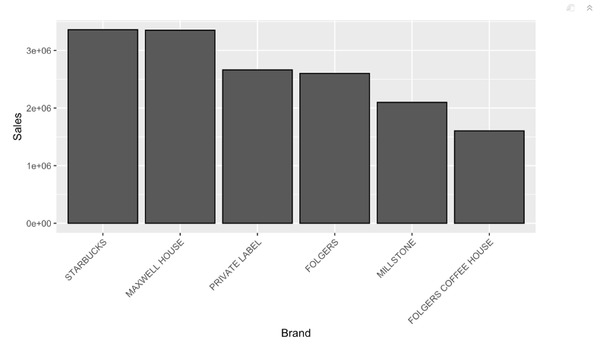

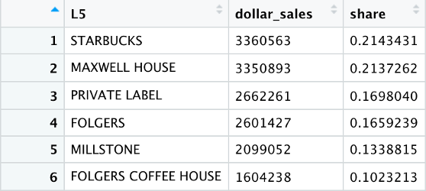

In terms of dollar sales (measured by Dollar Sales = Dollars/Units), our brand is a close competitor to Starbucks. Starbucks and Maxwell House appear to have about identical market share. Let's see if that's the case by running a t-test between Starbucks and Maxwell House mean dollar sales. KRAFT FOODS INC is the parent company of both brands.

**T-test comparing Maxwell House and Starbucks mean dollar sales**

**Null hypothesis:** Mean sales of Maxwell house = Mean sales of Starbucks

**Alternate hypothesis:** Mean sales of Maxwell house != Mean sales of Starbucks

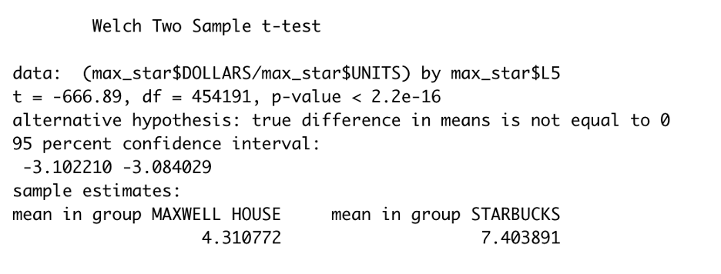

We reject the null hypothesis in favor of the alternate hypothesis based on the t-test and find that Maxwell House's mean dollar sales are significantly different from Starbucks' mean dollar sales. In reality, Maxwell House's average sales are lower than Starbucks'.

**KRAFT FOODS INC ‘s top 5 brands**

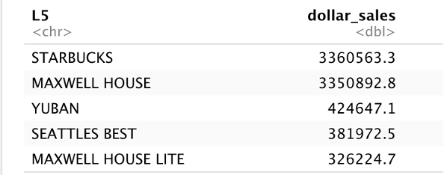

**The top five ground coffee brands within KRAFT FOODS INC.**

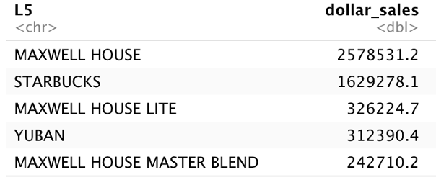

We can see, Starbucks has the highest dollar sales, but Maxwell House has the highest dollar sales in the ground coffee category.

**Top 5 regions where our brand sells the most**

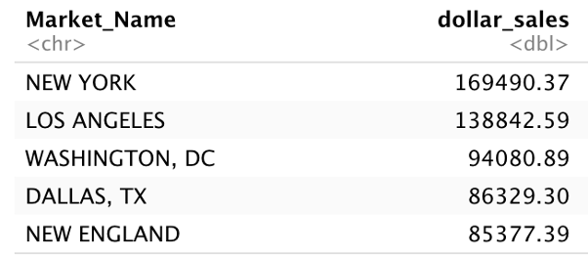

**Top 5 stores where our brand sells the most**

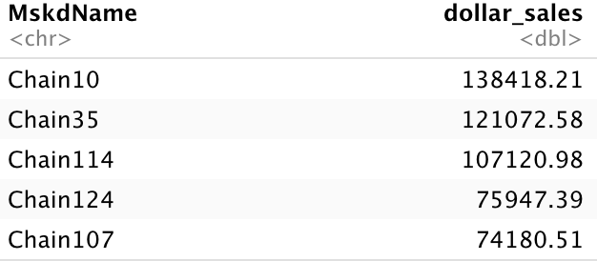

**The number of units sold every week for Maxwell House Ground Coffee is visualized by:**

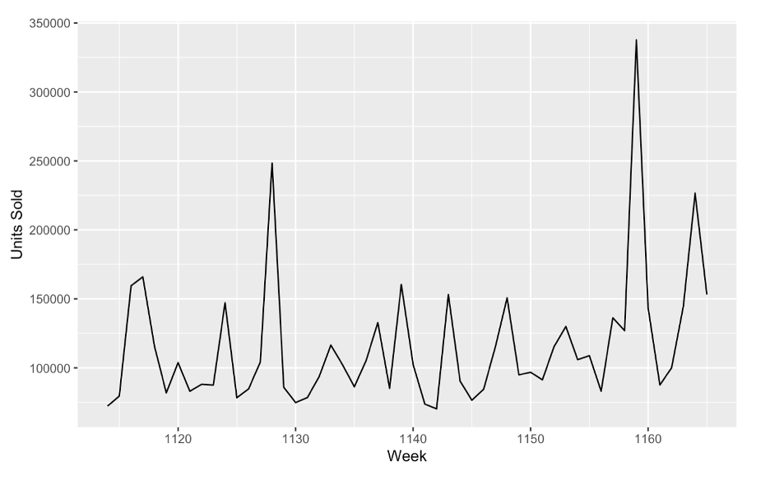

**Weekly price per ounce of Maxwell House Ground Coffee**

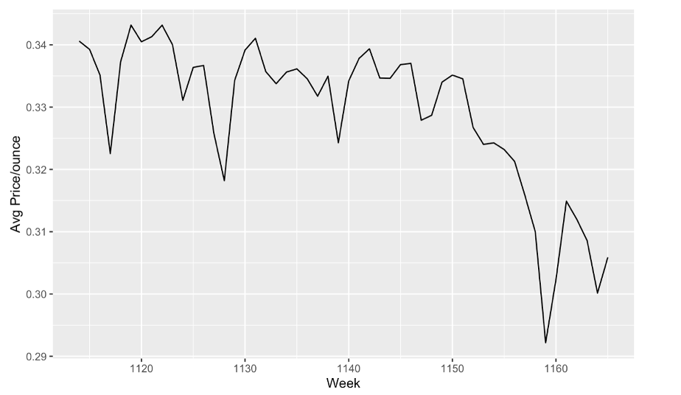

**Correlation of average price per ounce and Units sold**

Negative correlation of -70.83 between Units sold and average price per ounce has been found

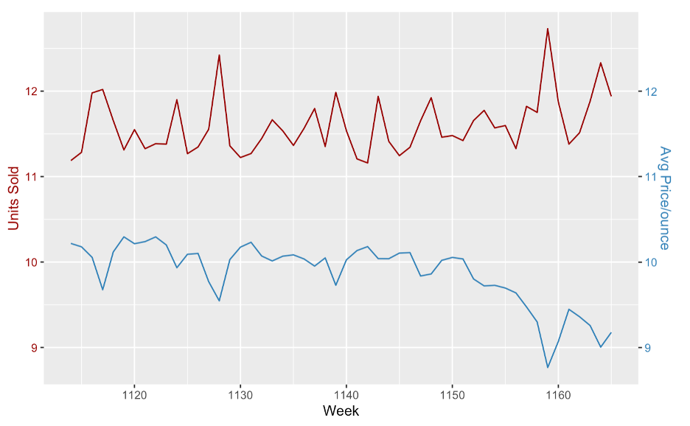

When the average price per ounce is lower, the number of units sold is larger, as expected.

**ANNOVA TEST FOR VARIOUS CATEGORICAL FEATURES:**

**Packaging:**

Null hypothesis: Dollar sales for all types of packaging are equal

Alternate hypothesis: Dollar sales for all types of packaging are not equal

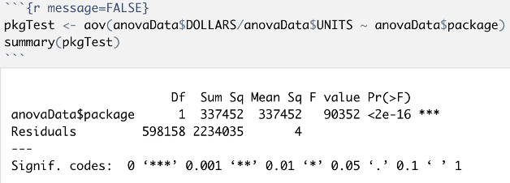

We can see that, the dollar sales of canned packing are significantly different from other varieties.

**Flavor:**

Null hypothesis: Dollar sales for all flavors are equal

Alternate hypothesis: Dollar sales for all flavors are not equal

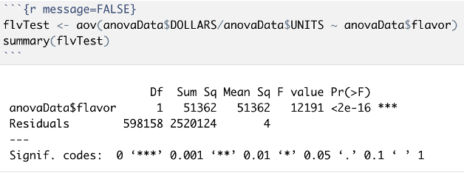

We can see that, the dollar sales of regular coffee varies greatly from those of various flavors.

**Brewing method:**

Null hypothesis: Dollar sales for all types of brewed coffee are equal

Alternate hypothesis: Dollar sales for all types of brewed coffee are not equal

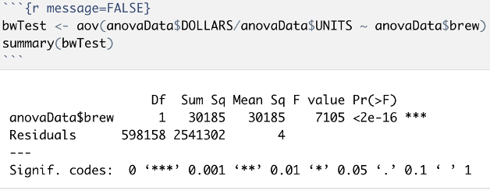

We can see that all-purpose coffee sells for more money than other types of coffee.

**DECRIPTIVE STATISTICS SUMMARY AND NEXT STEPS:**

From the descriptive statistics above, we know that Maxwell House is the leading brand in the ground coffee category. The main objective is to retain the leading position.

For the next step, we applied linear regression on various parameters and the results were:

| **Parameter** | **Estimate** | **T-value** | **STB** |
| --- | --- | --- | --- |
| Intercept | 56.51 | 123.88 | 0 |
| Large Ad | 26.044 | 134.37 | 0.179 |
| Small Ad | -1.181 | -1.45 | -0.0016 |
| Medium Ad | 24.76 | 105.2 | 0.1333 |
| Coupon | 7.80 | 21.61 | 0.0266 |
| Small screen display | -42.2 | -184 | -0.269 |
| Medium Screen Display | -21.78 | -56.63 | -0.079 |
| PR 0(Price reduced) | 0.267 | 2.43 | 0.003585 |

We can see that the units sold increase when they have been featured in an advertisement.(Although small Ad has a negative sign, it’s an insignificant estimate because t-value<1.96).

Also, when the estimates for Small Screen and Medium Screen displays are compared to the estimates for Large Screen displays, we can see that when a product is presented on a large screen, the units sold of the item are comparatively higher than when the item is displayed on a small or medium screen.

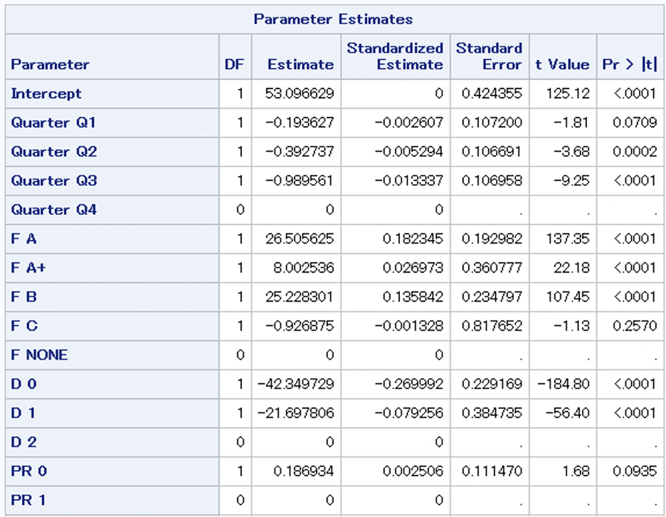

Also,

Here we can see that the Maxwell House had the most Number of sales in Quarter-4 followed by Quarter-1 ,Quarter-2 and quarter-3. We can say this at 90% Confidence level

**RECOMMENDATION FOR MARKETING**

1. Start advertising more, as the sales increase when products get featured in advertisements.
2. Display products on large screens. Products when displayed on large screens get sold more as compared to when displayed on small or medium screens.
3. The above 2 steps can be followed specially in the 2nd and 3rd quarter as the sales are minimum in these time of the year